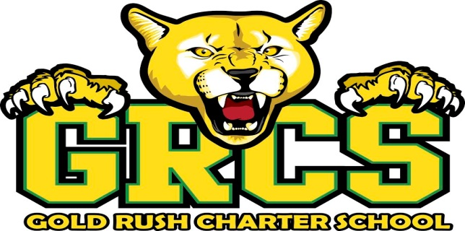

Board Meeting Agenda
GOLD RUSH CHARTER SCHOOL
Held at the Gold Rush Charter School Conference Room
19410 Village Dr., Sonora, CA 95370
Thursday, December 7th, 2017
4:00 PM

- CALL TO ORDER

  - Flag salute

- ROLL CALL AND ESTABLISHMENT OF A QUORUM

- APPROVAL OF AGENDA

- PUBLIC COMMENT

Because this is a public hearing, it is our time to hear from you. The Board reserves the right to limit the time of presentations by individuals and cumulative time. This time is set aside for items not on the agenda. The public may address the Board on agenda items immediately prior to them being considered by the Board. Though the Board generally will not respond, we are listening carefully. Depending on the nature of the presentation, the Board President or Executive Director may respond or the President may call upon Board members for brief comments, questions of clarification, provide a reference to staff or other resources for factual information, or request the Executive Director to report back to the Board at a subsequent meeting concerning the matter. However, in compliance with Board Policy and the Ralph M. Brown Act, the Board is not permitted to take action on non-agenda items. If appropriate, a Board member may direct the Executive Director to schedule an item for a future Board agenda.

- SHOWCASE
- EXECUTIVE DIRECTOR'S REPORT: BY RON HAMILTON
Ron Hamilton will report on activities and/or issues relevant to the sound management of the school as well as achievements and accomplishments of students and staff.

- FINANCIAL REPORT: BY RON HAMILTON

- BOARD MEMBERS' REPORTS
Board members may report on individual activities, issues, and other items of interest.

VOTING AGENDA

- CONSENT ITEMS

  - Meeting Minutes from November 16, 2017

- ACTION ITEMS

  - 1st Interim Budget

- CLOSED SESSION

  - Update: Grievance #001-2017

- RETURN TO OPEN SESSION and REPORT ACTION TAKEN

- FUTURE ITEMS

  - Board Self-Evaluation and Survey

- FUTURE MEETINGS

  - Thursday, January 18, 2017

- ADJOURNMENT

